Drink survey
Ask 10 pupils in your class which drinks they have had in the last two days. Write the initials of the pupil you are asking at the top of the column and tick the drinks they have had. If they have had drinks that are not on the list, tick the ‘other’ box and write these below.

Drink
Water
Milk
Fruit juice
Smoothie
Squash
Cola or lemonade
Diet cola or lemonade
Energy drink
Hot chocolate
Tea
Other

What other drinks did pupils have?

Use the information you have collected to create a bar chart like the one below.

Drinks 10 pupils had in two days

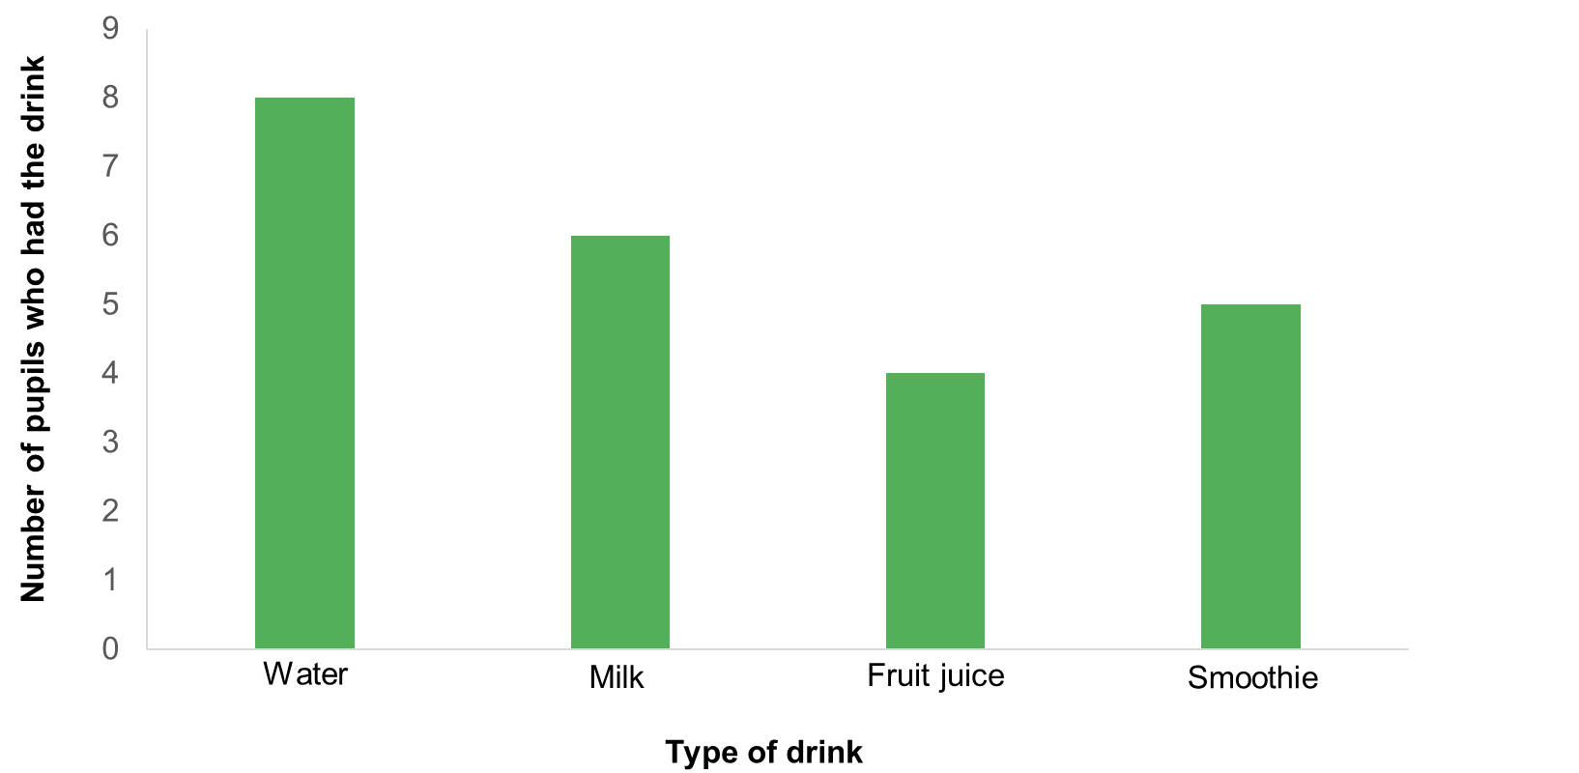

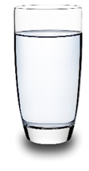
Questions

- Which drink was the most popular?

- Which drink was the least popular?

- Write an interesting fact that you have found out by completing your survey.

- Are these 10 pupils making healthy drink choices? Explain your answer.

- Can you give these pupils any tips to help them make healthier drink choices?

