Food waste or food wasted?  
Cut out the images. Sort them into those that could have been eaten and those that should go in the food waste bin.

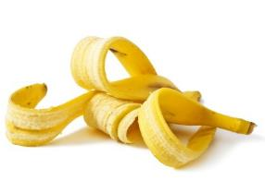

Food waste  
Food we need to put in the food waste bin.

Food wasted   
Food that could have been eaten.

